**CIMOR Access Instructions**

**Table of Contents**

CIMOR and Portal User Account Setup and Login Instructions 2

Changing Temporary Password Using Portal Page 3

Changing an Expired Password Using Portal Page 4

Logging into ARA to Request Roles 6

Changing Password Before it Expires 8

Changing Password Using the CIMOR Production Environment 10

# CIMOR and Portal User Account Setup and Login Instructions

The following is the basic setup for new users and log in errors in the CIMOR and Portal applications.

1. First, you will need an account to access the CIMOR or Portal page. A DMH Userid can be requested and updated using the Contract Provider Access Request Form. The link to this form is located on the DMH Portal page at [https://portal.dmh.mo.gov](https://portal.dmh.mo.gov/).
   * Upon clicking on the link to the Contract Provider Access Request Form, you will be redirected to the online FileBound application (<https://modmh.filebound.com/portal/93>) to fill out your request online and submit it to your Local Security Officer for approval.

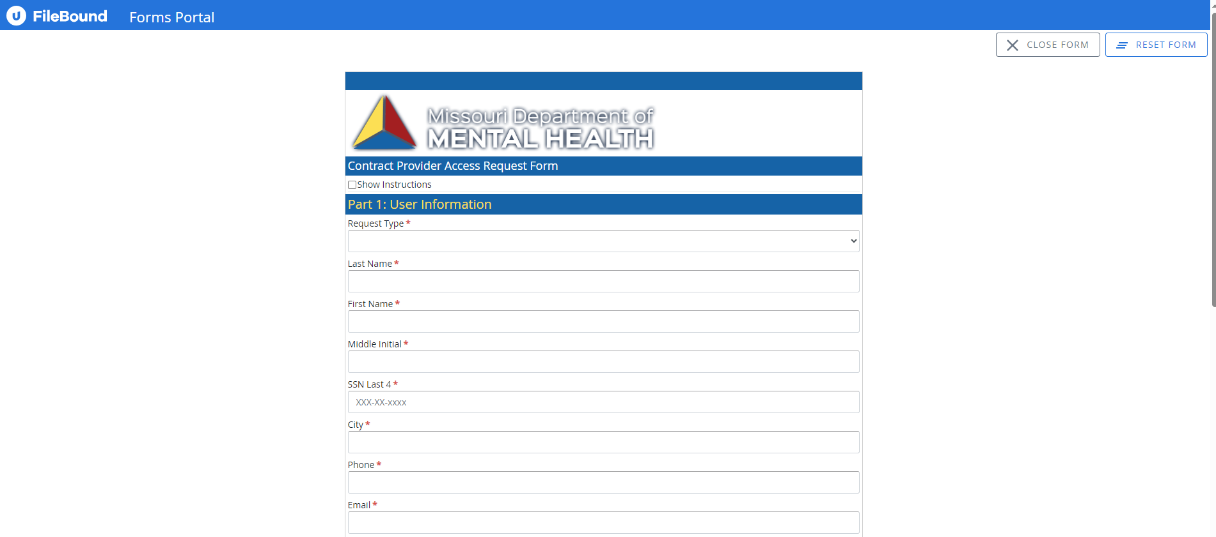

* + You may receive emails from the FileBound system as your request goes through the approval process. To ensure that you receive these important emails regarding your access request, please make sure that @filebound.com domain is ‘allowed’ as a safe sender in your email system.
  + If the URL is blocked by your firewall, please reach out to your IT department to resolve the issue.

1. You will receive an email with the User ID (myxxxxx) and a separate email with your temporary password that must be reset at your first log on. You will have 21 days to change your temporary password. If the temporary password is not changed within the first 21 days your account will be disabled and you will need to call the help desk **(888-601-4779)** to get the account enabled.
2. You will need to go to the portal page [https://portal.dmh.mo.gov.](https://portal.dmh.mo.gov/) It is recommended that this page be added to your favorites, as you will need to come back to it often.

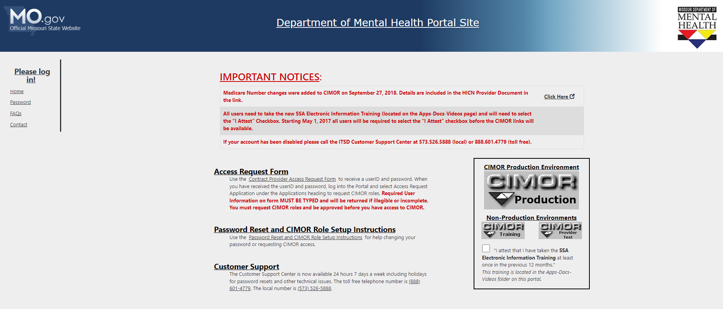

# 

# Changing Temporary Password Using Portal Page

1. On the portal page, click “Password” from the menu on the left. A new page will display with further instructions.

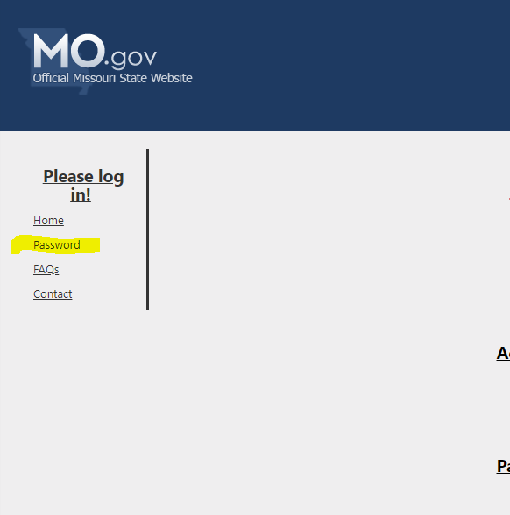

1. Read the instructions on the Password page and select “Update Password” at the bottom of the page. A new tab will open for you to enter your information.

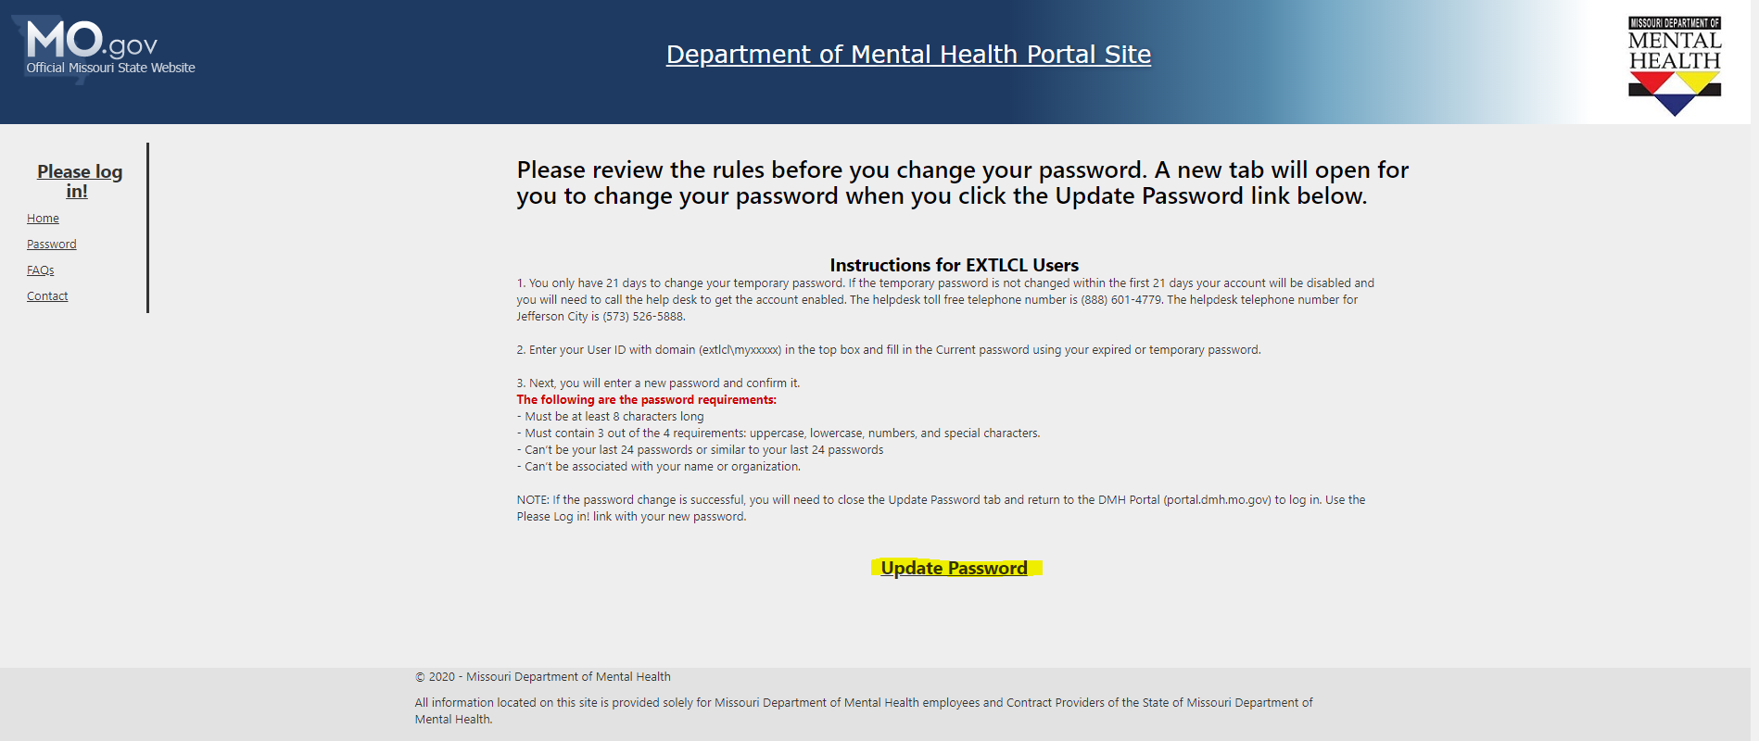

1. In the “Domain\Username” box, enter your user name including the domain “EXTLCL\myxxxxx”. In the “Old Password” box, enter your temporary password. In the “New password” and “Confirm new password” boxes, enter your new password. Make sure you follow the password rules from the portal instructions.

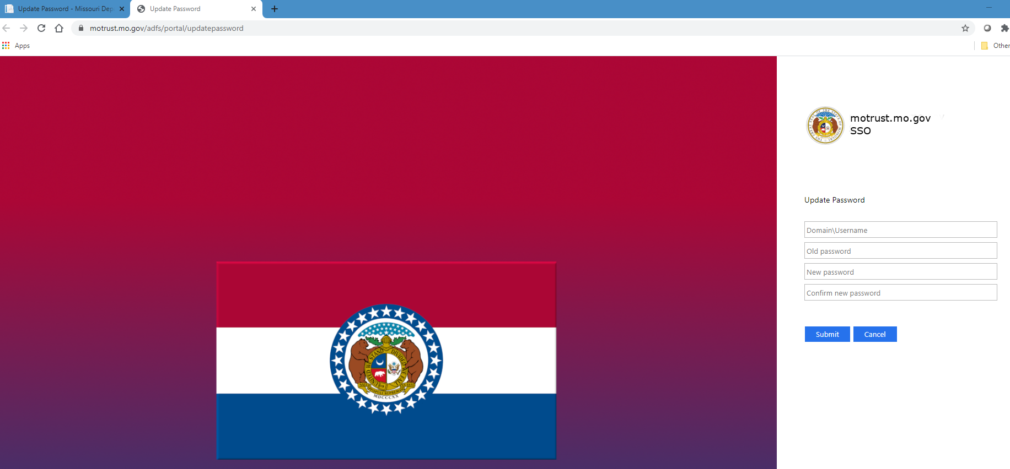

1. After you have successfully changed your temporary password, close the Update Password tab and return to the portal to sign in.

# Changing an Expired Password Using Portal Page

1. On the portal page click “Please log in!” If your password is expired, it will automatically prompt you to change the password. This is the same user name and password you use in CIMOR. The only difference is you must include the domain “EXTLCL\myxxxxx” with the user name. The domain is EXTLCL.

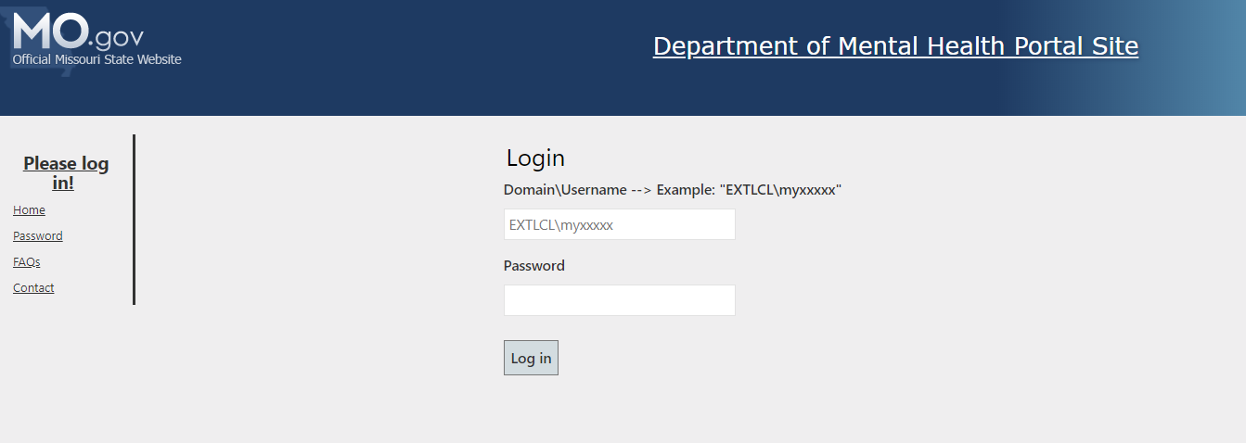

1. Read the instructions on the Password page and select “Update Password” at the bottom of the page. A new tab will open for you to enter your information.
2. In the “Domain\Username” box, enter your user name including the domain “EXTLCL\myxxxxx”. In the “Old Password” box, enter your expired password. In the “New password” and “Confirm new password” boxes, enter your new password. Make sure you follow the password rules from the portal instructions.



1. After you have successfully changed your temporary password, close the Update Password tab and return to the portal to sign in.

# Logging into ARA to Request Roles

1. Log in to the Portal page by selecting “Please Log in!” Enter your user name and password. You must include the domain “EXTLCL\myxxxxx” with the user name.



1. Once logged in to the Portal Page it should say “Hello, YOUR NAME”. Select Apps-Docs- Videos in the list located on the left side of the page.

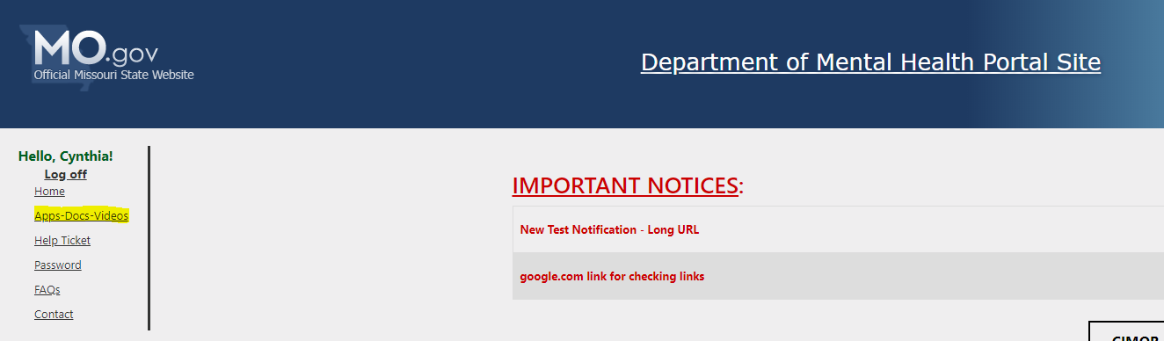

1. On the next screen, select the Access Request Application (ARA) – CIMOR Access under **Security Access Request**. If you are a DD provider, you can also find a help document for selecting your roles on this page.

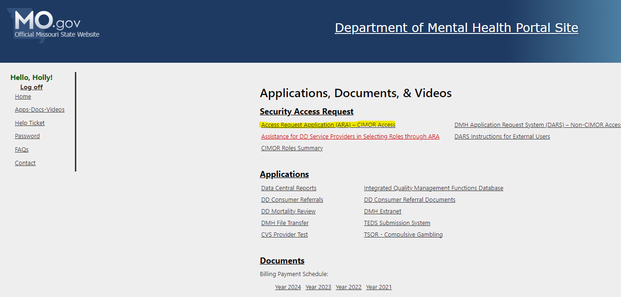

1. 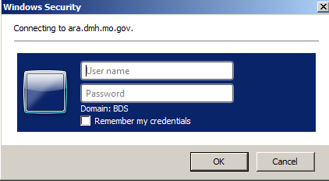The ARA login window will be the same as logging into the portal page, “EXTLCL\myxxxxx” and current password. DO NOT CHECK the “Remember my credentials” box as it can cause future problems when logging in. **NOTE**: If these steps do not let you log into ARA and you get an error message, you will need to follow the steps again but before typing in your credentials, click on More Choices and then in the email field type “EXTLCL\myxxxxx” and current password.
2. Once logged in you will see the following screen to assist you and your local security officer.

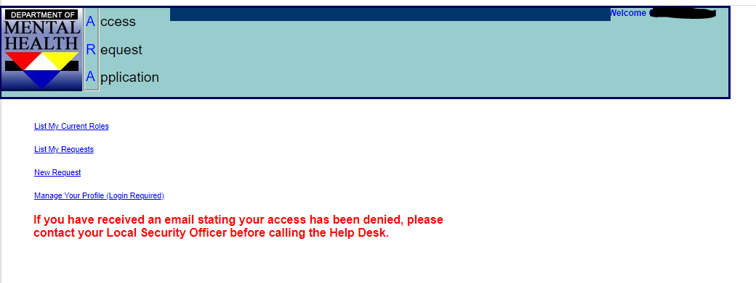

ITSD personnel do not have training in setting up the security roles; your local security officer will assist you through that part. You may also contact provider relations in your regional office for help with security roles.

# Changing Password Before it Expires

1. On the portal page, click “Password” from the menu on the left. A new page will display with further instructions.



1. Read the instructions on the Password page and select “Update Password” at the bottom of the page. A new tab will open for you to enter your information.



1. In the “Domain\Username” box, enter your user name including the domain “EXTLCL\myxxxxx”. In the “Old Password” box, enter your current password. In the “New password” and “Confirm new password” boxes, enter your new password. Make sure you follow the password rules from the portal instructions.



1. After you have successfully changed your temporary password, close the Update Password tab and return to the portal to sign in.

# Changing Password Using the CIMOR Production Environment

1. You have the option to change your password using the CIMOR Production Environment.
2. On the portal page, check the “I attest……” box and select the CIMOR Production Environment icon to be taken to the CIMOR login page or you can use the CIMOR link: <https://cimor.dmh.mo.gov/CIMORLogin.aspx>

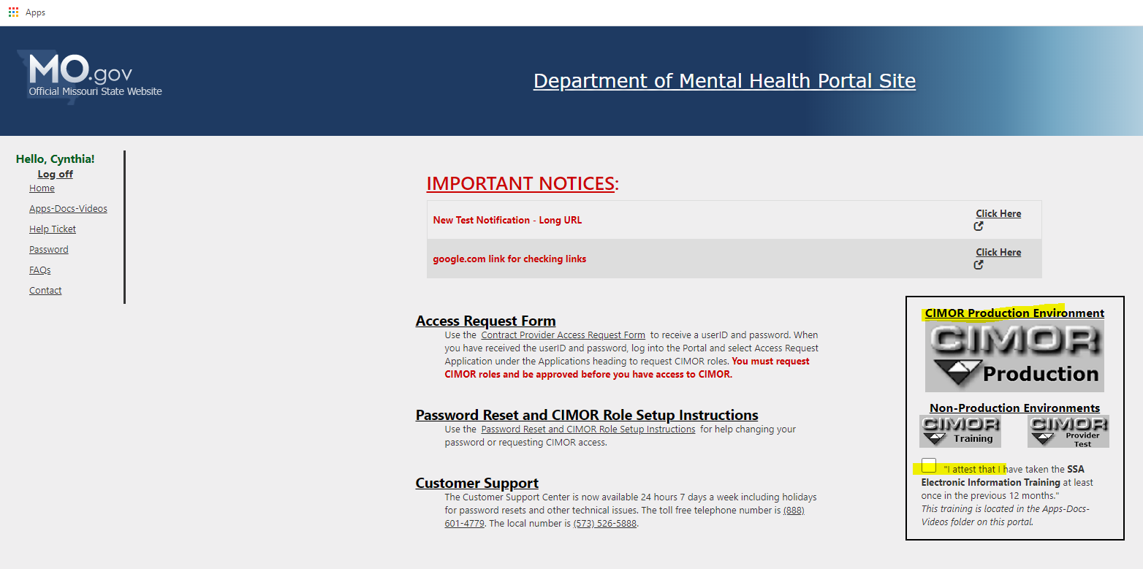

1. Enter your User ID (myxxxxx) and temporary password. Make sure EXTLCL is selected in the Domain* box. Review the SSA Training and then check the box “I attest…..” and select Login. You should get a message that the password has expired and must be changed before logging in.

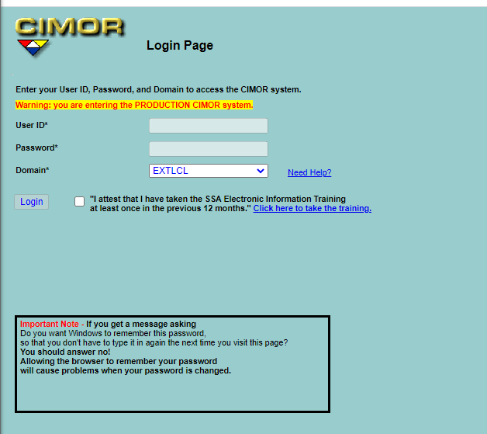

1. First, you will need to put your temporary or current password in the password box below the User ID. Next, you will add a new password and confirm it. The following are the password requirements:
   * Must be at least 8 characters long
   * Must contain 3 out of the 4 requirements: uppercase, Lowercase, numbers, and special characters.
   * Can’t be your last 24 passwords or similar to your last 24 passwords
   * Can’t be associated with your name or organization.

Please ignore any errors until after you have pressed the change password button. “NOTE: If you press Enter after the last box, the boxes are cleared and you will have to refill in the empty boxes”.

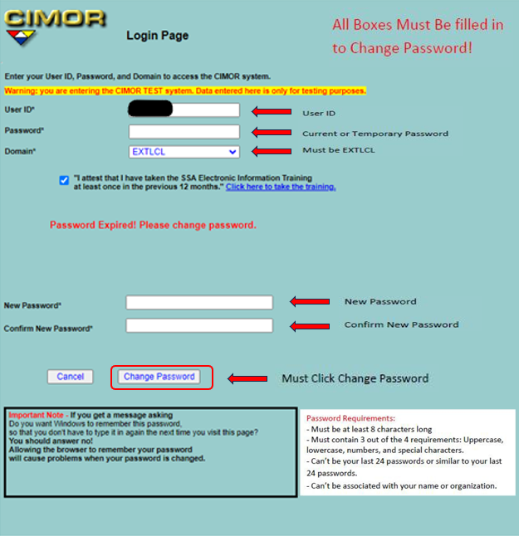

1. If the password change is successful, you will be taken to the CIMOR login screen where you can login with your new password. New users will receive a message “You are not authorized to view this page”. This is normal because you do not have security roles set up in CIMOR. SEE PAGE 6-7 FOR ASSISTANCE WITH LOGGING INTO ARA.